Dimension, measure, hypercube and listObject, what are them and how to use them in Extension.

What is dimension and measure?

Think of dimension as the rule to divide your data into small sets.

And measure as the measurement on these sets. It can be a single attribute or function (attribute 1 …. attribute n).

Qlik owns a huge database for the entire human race, containing information about age, race, gender, favourite fruit, DoB of every single person. (Actually we don’t)

So in the database, there are the following columns.

|  |  |  |  |  |  |
| --- | --- | --- | --- | --- | --- |
| ID | Race | Age | Gender | LikeFruit | Date of birth |

What is dimensions and measure:

single Dimension: Favourite fruit

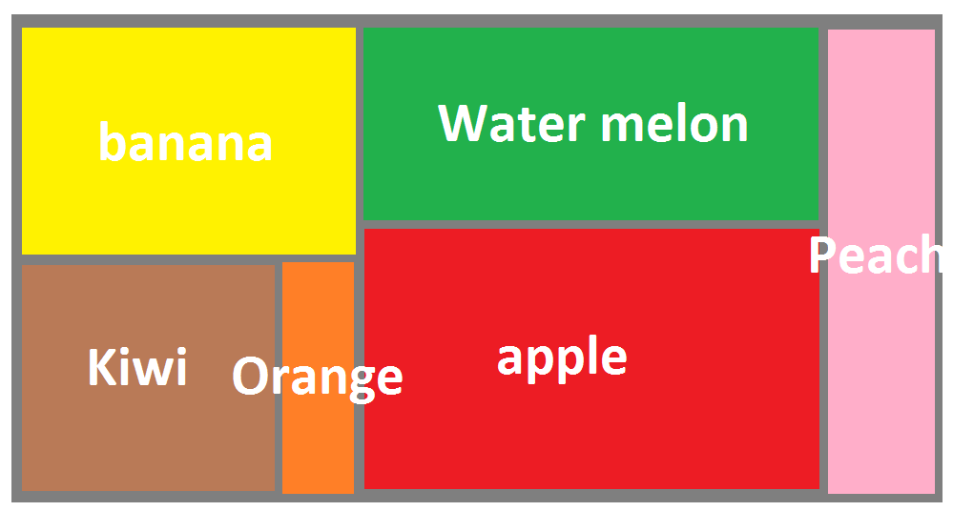

Two Dimension: favourite fruit and gender

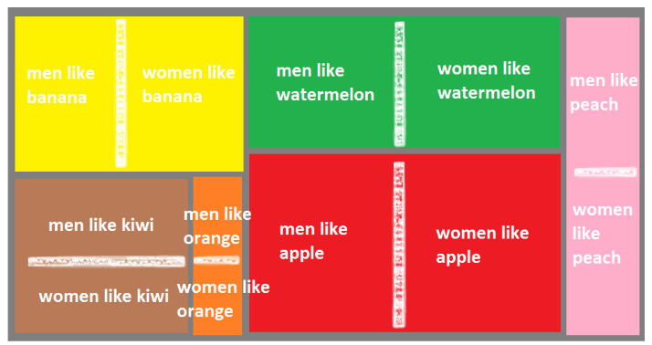

Two dimension + measure (count(id))

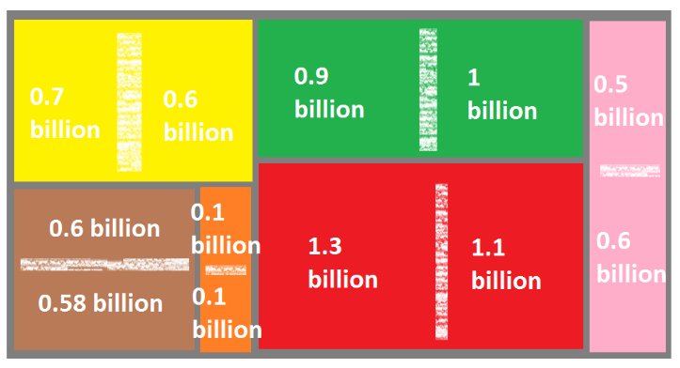

Now we are looking at a graph with two dimension and one measure - (count(id))- showing diversity base on gender and fruit preference, and that is dimension. You may choose any function to process any column (or combination of column), that is measure.

It is totally fine to have 20 dimensions and 20 measures (though no chart could represent that them), just remember:

Dimension: divide data into small sets

Measure: function (data in set)

In SQL term:

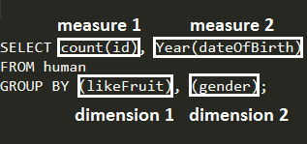

--------------------------Qlik data structure, Hypercube and List object-----------------------------------------

What is hypercube and list object?

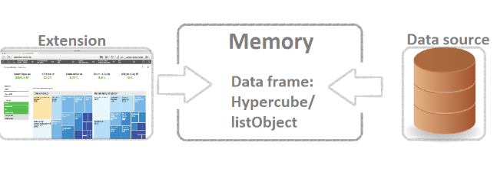

In Qlik, Data is transferred and stored in hypercube (n*dimension+ n*measure) or listObject (1*dimension, no measure). Hypercube is a conceptual data container used by Qlik. It contains all the necessary information for data visualization like dimension info, measure info, sorting information etc. And also there are many convenient Qlik wrapper like table API for hypercube.

Data hierarchy in Qlik

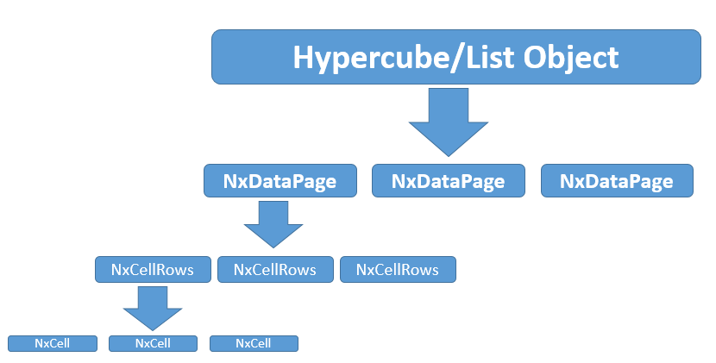

listObject and hypercube.

<https://help.qlik.com/en-US/sense-developer/3.0/Subsystems/Platform/Content/Concepts/Hypercubes.htm>

<https://help.qlik.com/en-US/sense-developer/3.0/Subsystems/Platform/Content/Concepts/Lists.htm>

NxDataPage

<https://help.qlik.com/en-US/sense-developer/3.0/Subsystems/EngineAPI/Content/Structs/NxDataPage.htm>

NxCellRows

https://help.qlik.com/en-US/sense-developer/2.2/Subsystems/EngineAPI/Content/Structs/NxCellRows.htm

NxCell

https://help.qlik.com/en-US/sense-developer/3.0/Subsystems/EngineAPI/Content/Structs/NxCell.htm

NxCell is the smallest unit of data here. In each NxCell, there is a qText property and a qNum property to represent the value. In visualization, for example a bar chart, one NxCell will be represented as one bar

Hypercube/ListObject is the top of data hierarchy. Both dimensions and measures are property of hypercube/list object.

In extension and mashups, you may use this.backendAPI to retreive the hypercube of your extension. (Your extension is a Generic Object which means it is a hypercube too!)

To get dimension property you can do:

NxDimensionInfo= this.backendAPI. getDimensionInfos[index].

NxDimensionInfo object is a generic object contains information of one dimension. And the actual data is fetched using backendAPI.getData(requestPage).

https://help.qlik.com/en-US/sense-developer/3.0/Subsystems/NetSDKAPI/Content/HowTos/Net-Sdk-How-To-Retrieving-Data.htm

Properties in NxDimensionInfo

https://help.qlik.com/en-US/sense-developer/3.0/Subsystems/NetSDKAPI/Content/HowTos/Net-Sdk-How-To-Retrieving-Data.htm

|  |  |  |
| --- | --- | --- |
| **Name** | **Description** | **Type** |
| **qFallbackTitle** | label of the dimension that is selected. | String |
| **qApprMaxGlyphCount** | Length of the longest value in the field. | Integer |
| **qCardinal** | Number of distinct field values. | Integer |
| **qLocked** | true if the field is locked. | Boolean |
| **qSortIndicator** | Sort indicator.  This parameter is optional.  The default value is no sorting. | * *N* for no sorting * *A* for sorting ascending * *D* for sorting descending |
| **qGroupFallbackTitles** | Array of dimension labels.  Contains the labels of all dimensions in a hierarchy group (for example the labels of all dimensions in a drill down group). | Array of String |
| **qGroupPos** | Index of the dimension that is currently in use.  *qGroupPos*is set to 0 if there are no hierarchical groups (drill-down groups) or cycle groups. | Integer |
| **qStateCounts** | Number of values in a particular state. | *NxStateCounts* |
| **qTags** | Gives information on a field. For example, it can return the type of the field.  Examples: key, text, ASCII | Array of String |
| **qError** | This parameter is optional.  Gives information on the error. | Null or *NxValidationError* |
| **qDimensionType** | Binary format of the field. | D for discrete (String)   * N for numeric (Double) * T for Time (Timestamp) |
| **qReverseSort** | If set to true, it inverts the sort criteria in the field. | Boolean |
| **qGrouping** | Defines the grouping. | * *N* for no grouping * *H* for drill-down * *C* for cyclic |
| **qIsSemantic** | If set to true, it means that the field is a semantic. | Boolean |
| **qNumFormat** | Format of the field.  This parameter is optional. | *FieldAttributes* |
| **qIsAutoFormat** | This parameter is set to true if *qNumFormat*is set to *U*(unknown). The engine guesses the type of the field based on the field's definition. | Boolean |
| **qGroupFieldDefs** | Array of field names. | Array of String |
| **qAttrExprInfo** | Array of attribute expressions. | Array of *NxAttrExprInfo* |
| **qMin** | Minimum value. | Double |
| **qMax** | Maximum value. | Double |
| **qContinuousAxes** | Is continuous axis used. | Boolean |
| **qIsCyclic** | Is a cyclic dimension used. | Boolean |
| **qDerivedField** | Is derived field is used as a dimension. | Boolean |

Similarly, measure property is NxMeasureInfo and it can be retrieved as:

NxMeasureInfo x= HyperCubeInfo.qMeasureInfo[index].

|  |  |  |
| --- | --- | --- |
| **Name** | **Description** | **Type** |
| **qFallbackTitle** | Corresponds to the label of the measure.  If the label is not defined then the measure name is used. | String |
| **qApprMaxGlyphCount** | Length of the longest value in the field. | Integer |
| **qCardinal** | Number of distinct field values. | Integer |
| **qSortIndicator** | Sort indicator.  This parameter is optional. The default value is no sorting. | *N* for no sorting  *A* for ascending  *D* for descending |
| **qNumFormat** | Format of the field.  This parameter is optional. | *FieldAttributes* |
| **qIsAutoFormat** | This parameter is set to true if *qNumFormat*is set to *U* (unknown). The engine guesses the type of the field based on the field's expression. | Boolean |
| **qMin** | Lowest value in the range. | Double precision floating point |